**STUDENT NAME: SHREYASH NARENDRA SAKPAL**

**CAR SHOWROOM DATABASE**

**MANAGEMENT SYSTEM**



**AIM OF PROJECT**

The aim of the Car Showroom Database Management System project is to design, develop, and implement a comprehensive and efficient database system using MySQL that facilitates the management and organization of a car showroom's data.

The primary objectives include:

**Data Organization and Storage**:

Create a structured database to systematically store information about cars, customers, employees, suppliers, transactions, and inventory.

**Inventory Management**:

Implement functionalities to manage and track the showroom's inventory, including details such as available car models, their specifications, quantity, prices, and their availability status.

**Customer Relationship Management**:

Develop a module to manage customer data, including their contact information, purchase history, preferences, enabling personalized services and marketing strategies.

**Sales and Transactions**:

Implement a system to handle sales transactions, including invoices, payment records, financing options, and other related details, ensuring accuracy and accountability.

**User-friendly Interface**:

Develop an intuitive and user-friendly interface allowing authorized personnel to easily access, modify, and retrieve data based on their roles within the showroom.

**Security and Access Control**:

Implement robust security measures to safeguard sensitive data, ensuring access controls based on user roles to maintain data integrity and confidentiality.

**Reporting and Analytics**:

Provide tools to generate comprehensive reports and analytical insights, aiding in decision-making processes and business strategies.

**Documentation and Maintenance**:

Create detailed documentation covering the system architecture, database schema, functionalities, and guidelines for maintenance and updates.

The successful implementation of the Car Showroom Database Management System aims to streamline operations, enhance customer satisfaction, improve inventory management, and facilitate better decision-making for the overall growth and efficiency of the car showroom business.

**ER DIAGRAM**

**CAR SALES**

customer_id,

c_id ,

customer_name,

state,

contact_no,

Purchase_date,

Purchase_price.

Export by

**CAR IMPORT**

import_id,

Model_type,

company_name,

import_date,

import_price.

Import by

**CAR_DESC**

car_id ,

Model_name,

Engine_type,

Transmission_type,

Horsepower,

Topspeed,

Fuel_type,

Mileage int not null,

Model_year,

Price

**TABLE DESCPRIPTION:**

**CAR_DESC:**

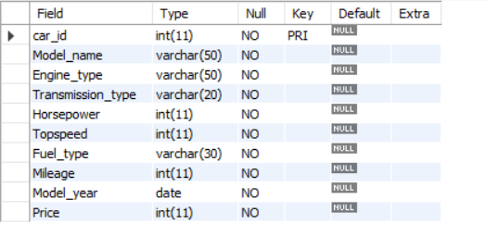

**CAR_IMPORT**

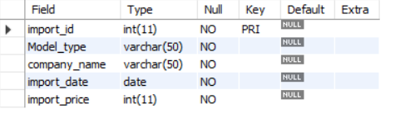

**CAR_SALES**

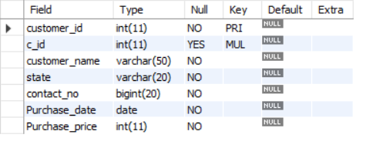

**COMMAND TO CREATE TABLES**

CREATE DATABASE:

create database car_showroom_dbms;

use car_showroom_dbms;

CREATE TABLE CAR_DESC:

create table car_desc(

car_id int primary key,

Model_name varchar(50) not null,

Engine_type varchar(50) not null,

Transmission_type varchar(20) not null,

Horsepower int not null,

Topspeed int not null,

Fuel_type varchar(30) not null,

Mileage int not null,

Model_year date not null,

Price int not null);

desc car_desc;

CREATE TABLE CAR_IMPORT:

create table car_import(

import_id int primary key,

Model_type varchar(50) not null,

company_name varchar(50) not null,

import_date date not null,

import_price int not null);

desc car_import;

CREATE TABLE CAR_SALES

create table car_sales(

customer_id int primary key,

c_id int,

constraint fk_c_id foreign key (c_id) REFERENCES car_desc(car_id) on delete cascade on update cascade,

customer_name varchar(50) not null,

state varchar(20) not null,

contact_no bigint not null,

Purchase_date date not null,

Purchase_price int not null);

desc car_sales;

show tables;

**COMMANDS TO INSERT VALUES IN TABLE**

**TABLE CAR_DESC:**

INSERT INTO car_desc VALUES

(1, 'Toyota Camry', 'Gasoline', 'Automatic', 203, 125, 'Petrol', 28, '2022-01-01', 25000),

(2, 'Honda Civic', 'Gasoline', 'Manual', 158, 118, 'Petrol', 32, '2022-01-01', 22000),

(3, 'Ford Mustang', 'Gasoline', 'Automatic', 450, 155, 'Petrol', 20, '2022-01-01', 45000),

(4, 'Tesla Model S', 'Electric', 'Automatic', 670, 155, 'Electric', 95, '2022-01-01', 80000),

(5, 'BMW 3 Series', 'Gasoline', 'Automatic', 255, 155, 'Petrol', 26, '2022-01-01', 40000),

(6, 'Audi A4', 'Gasoline', 'Automatic', 201, 130, 'Petrol', 30, '2022-01-01', 35000),

(7, 'Mercedes-Benz C-Class', 'Gasoline', 'Automatic', 255, 155, 'Petrol', 28, '2022-01-01', 50000),

(8, 'Chevrolet Corvette', 'Gasoline', 'Automatic', 490, 184, 'Petrol', 19, '2022-01-01', 60000),

(9, 'Nissan Altima', 'Gasoline', 'Automatic', 188, 125, 'Petrol', 32, '2022-01-01', 23000),

(10, 'Hyundai Elantra', 'Gasoline', 'Automatic', 147, 124, 'Petrol', 35, '2022-01-01', 20000),

(11, 'Volvo S60', 'Gasoline', 'Automatic', 250, 145, 'Petrol', 30, '2022-01-01', 45000),

(12, 'Mazda MX-5 Miata', 'Gasoline', 'Manual', 181, 135, 'Petrol', 29, '2022-01-01', 30000),

(13, 'Subaru WRX', 'Gasoline', 'Manual', 268, 150, 'Petrol', 24, '2022-01-01', 35000),

(14, 'Lexus ES', 'Gasoline', 'Automatic', 302, 131, 'Petrol', 26, '2022-01-01', 48000),

(15, 'Kia Optima', 'Gasoline', 'Automatic', 185, 132, 'Petrol', 33, '2022-01-01', 24000),

(16, 'Toyota Corolla', 'Gasoline', 'Automatic', 139, 115, 'Petrol', 30, '2022-01-01', 20000),

(17, 'Honda Accord', 'Gasoline', 'Automatic', 192, 127, 'Petrol', 29, '2022-01-01', 26000),

(18, 'Ford F-150', 'Gasoline', 'Automatic', 290, 120, 'Petrol', 23, '2022-01-01', 35000),

(19, 'Tesla Model 3', 'Electric', 'Automatic', 283, 140, 'Electric', 75, '2022-01-01', 55000),

(20, 'BMW 5 Series', 'Gasoline', 'Automatic', 335, 155, 'Petrol', 24, '2022-01-01', 52000),

(21, 'Audi Q5', 'Gasoline', 'Automatic', 261, 135, 'Petrol', 27, '2022-01-01', 45000),

(22, 'Mercedes-Benz E-Class', 'Gasoline', 'Automatic', 362, 155, 'Petrol', 25, '2022-01-01', 60000),

(23, 'Chevrolet Silverado', 'Gasoline', 'Automatic', 355, 130, 'Petrol', 20, '2022-01-01', 40000),

(24, 'Nissan Rogue', 'Gasoline', 'Automatic', 170, 125, 'Petrol', 28, '2022-01-01', 27000),

(25, 'Hyundai Sonata', 'Gasoline', 'Automatic', 191, 122, 'Petrol', 31, '2022-01-01', 23000),

(26, 'Volvo XC60', 'Gasoline', 'Automatic', 316, 140, 'Petrol', 26, '2022-01-01', 48000),

(27, 'Mazda CX-5', 'Gasoline', 'Automatic', 187, 130, 'Petrol', 29, '2022-01-01', 29000),

(28, 'Subaru Outback', 'Gasoline', 'Automatic', 182, 135, 'Petrol', 28, '2022-01-01', 32000),

(29, 'Lexus RX', 'Gasoline', 'Automatic', 295, 124, 'Petrol', 27, '2022-01-01', 55000),

(30, 'Kia Sorento', 'Gasoline', 'Automatic', 191, 121, 'Petrol', 29, '2022-01-01', 28000);

select * from car_desc;

**TABLE CAR_IMPORT:**

INSERT INTO car_import VALUES

(1001, 'Toyota Camry', 'Toyota', '2022-02-01', 23000),

(1002, 'Honda Civic', 'Honda', '2022-03-15', 20000),

(1003, 'Ford Mustang', 'Ford', '2022-04-20', 42000),

(1004, 'Tesla Model S', 'Tesla', '2022-05-10', 75000),

(1005, 'BMW 3 Series', 'BMW', '2022-06-28', 38000),

(1006, 'Audi A4', 'Audi', '2022-07-12', 34000),

(1007, 'Mercedes-Benz C-Class', 'Mercedes-Benz', '2022-08-05', 48000),

(1008, 'Chevrolet Corvette', 'Chevrolet', '2022-09-22', 58000),

(1009, 'Nissan Altima', 'Nissan', '2022-10-18', 21000),

(1010, 'Hyundai Elantra', 'Hyundai', '2022-11-30', 19000),

(1011, 'Volvo S60', 'Volvo', '2022-12-25', 42000),

(1012, 'Mazda MX-5 Miata', 'Mazda', '2023-01-14', 28000),

(1013, 'Subaru WRX', 'Subaru', '2023-02-08', 33000),

(1014, 'Lexus ES', 'Lexus', '2023-03-20', 45000),

(1015, 'Kia Optima', 'Kia', '2023-04-05', 22000),

(1016, 'Toyota Corolla', 'Toyota', '2023-05-01', 19000),

(1017, 'Honda Accord', 'Honda', '2023-06-10', 24000),

(1018, 'Ford F-150', 'Ford', '2023-07-15', 32000),

(1019, 'Tesla Model 3', 'Tesla', '2023-08-20', 51000),

(1020, 'BMW 5 Series', 'BMW', '2023-09-25', 48000),

(1021, 'Audi Q5', 'Audi', '2023-10-30', 42000),

(1022, 'Mercedes-Benz E-Class', 'Mercedes', '2023-11-02', 57000),

(1023, 'Chevrolet Silverado', 'Chevrolet', '2023-12-05', 38000),

(1024, 'Nissan Rogue', 'Nissan', '2024-01-10', 25000),

(1025, 'Hyundai Sonata', 'Hyundai', '2024-02-15', 21000),

(1026, 'Volvo XC60', 'Volvo', '2024-03-20', 46000),

(1027, 'Mazda CX-5', 'Mazda', '2024-04-25', 27000),

(1028, 'Subaru Outback', 'Subaru', '2024-05-30', 30000),

(1029, 'Lexus RX', 'Lexus', '2024-06-05', 53000),

(1030, 'Kia Sorento', 'Kia', '2024-07-10', 26000);

select * from car_import;

**TABLE CAR_SALES:**

INSERT INTO car_sales VALUES

(201, 1, 'Raj kadam', 'California', 1234567890, '2023-05-01', 27000),

(202, 2, 'Ganesh gurav', 'New York', 1987654321, '2023-06-10', 21000),

(203, 3, 'Rohit waje', 'Texas', 1357924680, '2023-07-15', 44000),

(204, 4, 'Shreyash sakpal', 'Florida', 1765432987, '2023-08-20', 78000),

(205, 5, 'Sejal bhekare', 'California', 1654329870, '2023-09-25', 36000),

(206, 6, 'Kapil ghag', 'New York', 1890765432, '2023-10-30', 32000),

(207, 7, 'Vishal rajbhar', 'Texas', 1209876543, '2023-11-02', 50000),

(208, 8, 'Sanket khamkar', 'Florida', 1324509876, '2023-12-05', 62000),

(209, 9, 'kalyani patel', 'California', 1789054321, '2024-01-10', 25000),

(210, 10, 'Priti yadav', 'New York', 1543210987, '2024-02-15', 23000),

(211, 11, 'Angali tripathi', 'Texas', 1908765432, '2024-03-20', 46000),

(212, 12, 'Arun ovhal', 'Florida', 1123456789, '2024-04-25', 31000),

(213, 13, 'Siddhesh bhekare', 'California', 1567890123, '2024-05-30', 37000),

(214, 14, 'Siddhay shetye ', 'New York', 1432098765, '2024-06-05', 49000),

(215, 15, 'Manav sawardekar', 'Texas', 1976543210, '2024-07-10', 26000),

(216, 16, 'Rutik adekar', 'California', 1098765432, '2024-08-01', 21000),

(217, 17, 'Sonal patil', 'New York', 1876543210, '2024-09-10', 27000),

(218, 18, 'Amey shigwan', 'Texas', 1654321098, '2024-10-15', 34000),

(219, 19, 'Yash kasar', 'Florida', 1432109876, '2024-11-20', 58000),

(220, 20, 'Aditya chavan', 'California', 1209876543, '2024-12-25', 26000),

(221, 21, 'Sumeet sannak', 'New York', 1987654321, '2025-01-30', 32000),

(222, 22, 'Sarthak redij', 'Texas', 1765432109, '2025-02-05', 51000),

(223, 23, 'Vandesh chavan', 'Florida', 1543210987, '2025-03-10', 63000),

(224, 24, 'Yuvraj kadam', 'California', 1321098765, '2025-04-15', 24000),

(225, 25, 'Shantanu chavan', 'New York', 1098765432, '2025-05-20', 22000),

(226, 26, 'Afnan sabale', 'Texas', 1876543210, '2025-06-25', 42000),

(227, 27, 'Karina kadam', 'Floridaa', 1654321098, '2025-07-30', 29000),

(228, 28, 'Isha kadam', 'California', 1432109876, '2025-08-05', 33000),

(229, 29, 'Narendra sakpal', 'New York', 1209876543, '2025-09-10', 50000),

(230, 30, 'Anita kadam', 'Texas', 1987654321, '2025-10-15', 25000);

select * from car_sales;

**QUERIES**

#Total number of cars imported by each company:

select company_name, COUNT(*) as Total_Imports from car_import group by company_name;

|  |  |
| --- | --- |
| COMPANY_NAME | TABLE_IMPORT |
| Audi | 2 |
| BMW | 2 |
| Chevrolet | 2 |
| Ford | 2 |
| Honda | 2 |
| Hyundai | 2 |
| Kia | 2 |
| Lexus | 2 |
| Mazda | 2 |
| Mercedes | 1 |
| Mercedes-Benz | 1 |
| Nissan | 2 |
| Subaru | 2 |
| Tesla | 2 |
| Toyota | 2 |
| Volvo | 2 |

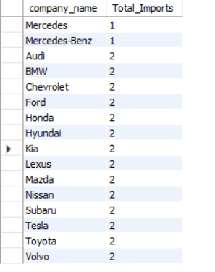

#Average purchase price of cars sold in California:

select avg(Purchase_price) as Average_Price_California from car_sales where state = 'California';

|  |
| --- |
| AVERAGE_PRICE_CALIFORNIA |
| 28625.0000 |



#Number of cars sold in each state:

select state, COUNT(*) as Cars_Sold from car_sales group by state;

|  |  |
| --- | --- |
| STATE | CAR_SOLD |
| California | 8 |
| Florida | 5 |
| Floridaa | 1 |
| New York | 8 |
| Texas | 8 |

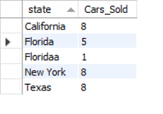

#Customers who bought cars with a purchase price above $40,000:

select * from car_sales where Purchase_price > 40000;

|  |  |  |  |  |  |  |
| --- | --- | --- | --- | --- | --- | --- |
| CUSTOMER_ID | C_ID | CUSTOMER_NAME | STATE | CONTACT_NO | PURCHASE_DATE | PURCHASE_PRICE |
| 203 | 3 | Rohit waje | Texas | 1357924680 | 2023-07-15 | 44000 |
| 204 | 4 | Shreyash sakpal | Florida | 1765432987 | 2023-08-20 | 78000 |
| 207 | 7 | Vishal rajbhar | Texas | 1209876543 | 2023-11-02 | 50000 |
| 208 | 8 | Sanket khamkar | Florida | 1324509876 | 2023-12-05 | 62000 |
| 211 | 11 | Angali tripathi | Texas | 1908765432 | 2024-03-20 | 46000 |
| 214 | 14 | Siddhay shetye | New York | 1432098765 | 2024-06-05 | 49000 |
| 219 | 19 | Yash kasar | Florida | 1432109876 | 2024-11-20 | 58000 |
| 222 | 22 | Sarthak redij | Texas | 1765432109 | 2025-02-05 | 51000 |
| 223 | 23 | Vandesh chavan | Florida | 1543210987 | 2025-03-10 | 63000 |
| 226 | 26 | Afnan sabale | Texas | 1876543210 | 2025-06-25 | 42000 |
| 229 | 29 | Narendra sakpal | New York | 1209876543 | 2025-09-10 | 50000 |
|  |  |  |  |  |  |  |

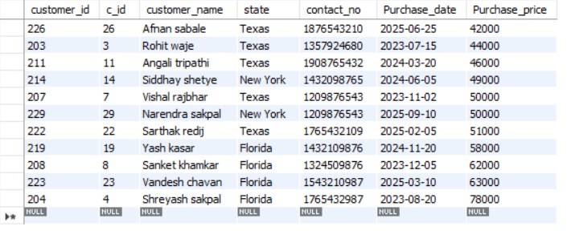

#Models imported before 2023:

select * from car_import where year(import_date) < 2023;

|  |  |  |  |  |
| --- | --- | --- | --- | --- |
| IMPORT_ID | MODEL_TYPE | COMPANY_NAME | IMPORT_DATE | IMPORT_PRICE |
| 1001 | Toyota Camry | Toyota | 2022-02-01 | 23000 |
| 1002 | Honda Civic | Honda | 2022-03-15 | 20000 |
| 1003 | Ford Mustang | Ford | 2022-04-20 | 42000 |
| 1004 | Tesla Model S | Tesla | 2022-05-10 | 75000 |
| 1005 | BMW 3 Series | BMW | 2022-06-28 | 38000 |
| 1006 | Audi A4 | Audi | 2022-07-12 | 34000 |
| 1007 | Mercedes-Benz C-Class | Mercedes-Benz | 2022-08-05 | 48000 |
| 1008 | Chevrolet Corvette | Chevrolet | 2022-09-22 | 58000 |
| 1009 | Nissan Altima | Nissan | 2022-10-18 | 21000 |
| 1010 | Hyundai Elantra | Hyundai | 2022-11-30 | 19000 |
| 1011 | Volvo S60 | Volvo | 2022-12-25 | 42000 |
|  |  |  |  |  |

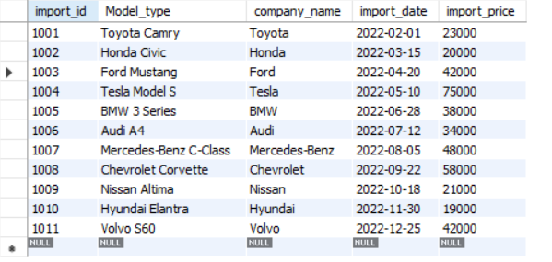

#Details of cars with a mileage greater than 50:

select * from car_desc where Mileage > 50;

|  |  |  |  |  |  |  |  |  |  |
| --- | --- | --- | --- | --- | --- | --- | --- | --- | --- |
| Car_id | Model_name | Engine_type | Transmission_type | horsepower | topspeed | Fuel_type | mileage | Model_year | price |
| 4 | Tesla Model S | Electric | Automatic | 670 | 155 | Electric | 95 | 2022-01-01 | 80000 |
| 19 | Tesla Model 3 | Electric | Automatic | 283 | 140 | Electric | 75 | 2022-01-01 | 55000 |
| 1005 | Tesla Model S | Electric | Automatic | 1020 | 200 | Electric | 350 | 2022-01-01 | 90000 |
| 1014 | Toyota Prius | Inline-4 Hybrid | CVT | 121 | 112 | Hybrid | 52 | 2022-01-01 | 28000 |
| 1018 | Tesla Model Y | Electric | Automatic | 384 | 155 | Electric | 326 | 2022-01-01 | 60000 |
|  |  |  |  |  |  |  |  |  |  |

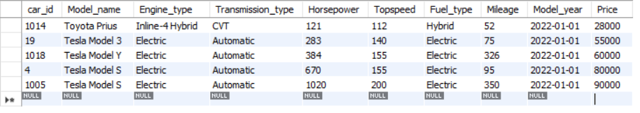

#Customers who purchased cars in 2024 and their contact numbers:

select customer_name, contact_no from car_sales where year(Purchase_date) = 2024

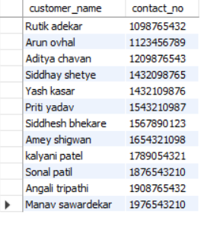

|  |  |
| --- | --- |
| CUSTOMER_NAME | CONTACT_N0 |
| kalyani patel | 1789054321 |
| Priti yadav | 1543210987 |
| Angali tripathi | 1908765432 |
| Arun ovhal | 1123456789 |
| Siddhesh bhekare | 1567890123 |
| Siddhay shetye | 1432098765 |
| Manav sawardekar | 1976543210 |
| Rutik adekar | 1098765432 |
| Sonal patil | 1876543210 |
| Amey shigwan | 1654321098 |
| Yash kasar | 1432109876 |
| Aditya Chavan | 1209876543 |

#Get the car models with their respective fuel types and mileages where mileages is greater than 90 or Fuel_type is electric:

select Model_name, Fuel_type, Mileage from car_desc where mileage>90 or Fuel_type="electric" ;

|  |  |  |
| --- | --- | --- |
| Model_name | Fuel_type | mileage |
| Tesla Model S | Electric | 95 |
| Tesla Model S | Electric | 350 |
| Tesla Model Y | Electric | 326 |

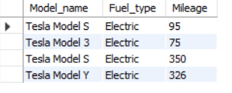

#Find customers who bought cars from California and their purchase dates:

select customer_name, Purchase_date, state from car_sales where state = 'California';

|  |  |  |
| --- | --- | --- |
| Customer_name | Purchase_date | state |
| Raj kadam | 2023-05-01 | California |
| Sejal bhekare | 2023-09-25 | California |
| kalyani patel | 2024-01-10 | California |
| Siddhesh bhekare | 2024-05-30 | California |
| Rutik adekar | 2024-08-01 | California |
| Aditya chavan | 2024-12-25 | California |
| Yuvraj kadam | 2025-04-15 | California |
| Isha kadam | 2025-08-05 | California |

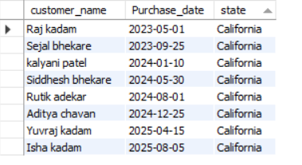

#Get the car models and their respective prices ordered by price in descending order:

select Model_name, Price from car_desc order by Price desc;

|  |  |
| --- | --- |
|  |  |
| Tesla Model S | 90000 |
| Tesla Model S | 80000 |
| Chevrolet Corvette | 65000 |
| Chevrolet Corvette | 60000 |
| Mercedes-Benz E-Class | 60000 |
| Mercedes-Benz E-Class | 60000 |
| Tesla Model Y | 60000 |
| Tesla Model 3 | 55000 |
| Lexus RX | 55000 |
| Audi A6 | 55000 |
| BMW 5 Series | 52000 |
| BMW 5 Series | 50000 |
| Mercedes-Benz C-Class | 50000 |
| Lexus ES | 48000 |
| Mercedes-Benz C-Class | 48000 |
| Volvo XC60 | 48000 |
| Ford Mustang | 45000 |
| Volvo S60 | 45000 |
| Audi Q5 | 45000 |
| Audi A4 | 42000 |
| Chevrolet Silverado | 40000 |
| Ford Explorer | 40000 |
| BMW 3 Series | 40000 |
| Ford Mustang | 40000 |
| BMW 3 Series | 35000 |
| Ford F-150 | 35000 |
| Audi A4 | 35000 |
| Subaru WRX | 35000 |
| Subaru Outback | 32000 |
| Volkswagen Golf GTI | 32000 |
| Subaru Outback | 32000 |
| Chevrolet Equinox | 32000 |
| Toyota RAV4 | 30000 |
| Mazda MX-5 Miata | 30000 |
| Mazda CX-5 | 29000 |
| Nissan Rogue | 29000 |
| Honda CR-V | 29000 |
| Toyota Prius | 28000 |
| Kia Sorento | 28000 |
| Subaru Crosstrek | 28000 |
| Kia Optima | 27000 |
| Nissan Rogue | 27000 |
| Honda HR-V | 27000 |
| Volkswagen Golf | 27000 |
| Hyundai Sonata | 26000 |
| Kia Seltos | 26000 |
| Honda Accord | 26000 |
| Toyota Camry | 25000 |
| Chevrolet Malibu | 25000 |
| Toyota Camry | 25000 |
| Kia Optima | 24000 |
| Ford Focus | 24000 |
| Hyundai Sonata | 23000 |
| Nissan Altima | 23000 |
| Hyundai Elantra | 23000 |
| Nissan Altima | 23000 |
| Honda Civic | 22000 |
| Honda Civic | 22000 |
| Toyota Corolla | 20000 |
| Hyundai Elantra | 20000 |

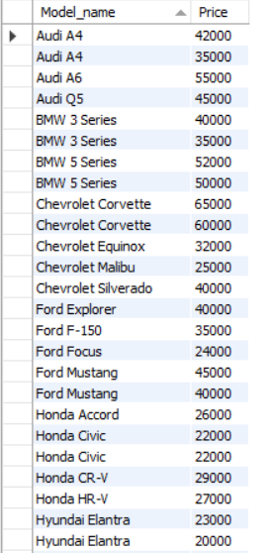

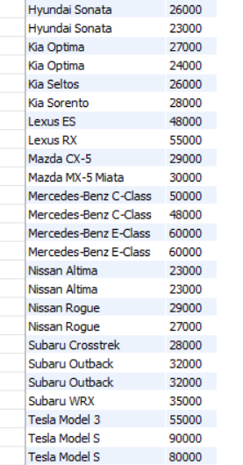

**SUB QUERIES**

#Details of cars sold with a purchase price above the average purchase price:

select * from car_sales where Purchase_price > (select avg(Purchase_price) from car_sales);

|  |  |  |  |  |  |  |
| --- | --- | --- | --- | --- | --- | --- |
| Customer_id | C_id | Customer_name | state | Contact_no | Purchase_date | Purchase_price |
| 203 | 3 | Rohit waje | Texas | 1357924680 | 2023-07-15 | 44000 |
| 204 | 4 | Shreyash sakpal | Florida | 1765432987 | 2023-08-20 | 78000 |
| 207 | 7 | Vishal rajbhar | Texas | 1209876543 | 2023-11-02 | 50000 |
| 208 | 8 | Sanket khamkar | Florida | 1324509876 | 2023-12-05 | 62000 |
| 211 | 11 | Angali tripathi | Texas | 1908765432 | 2024-03-20 | 46000 |
| 214 | 14 | Siddhay shetye | New York | 1432098765 | 2024-06-05 | 49000 |
| 219 | 19 | Yash kasar | Florida | 1432109876 | 2024-11-20 | 58000 |
| 222 | 22 | Sarthak redij | Texas | 1765432109 | 2025-02-05 | 51000 |
| 223 | 23 | Vandesh chavan | Florida | 1543210987 | 2025-03-10 | 63000 |
| 226 | 26 | Afnan sabale | Texas | 1876543210 | 2025-06-25 | 42000 |
| 229 | 29 | Narendra sakpal | New York | 1209876543 | 2025-09-10 | 50000 |

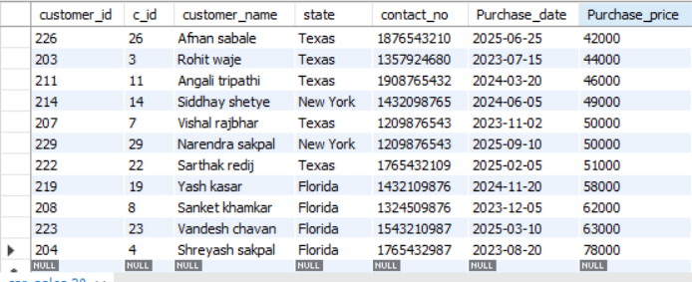

#Details of customers who purchased a Tesla:

select * from car_sales where c_id in (select car_id from car_desc where Model_name like 'Tesla%');

|  |  |  |  |  |  |  |
| --- | --- | --- | --- | --- | --- | --- |
| CUSTOMER_ID | C_ID | CUSTOMER_NAME | STATE | CONTACT_NO | PURCHASE_DATE | PURCHASE_PRICE |
| 204 | 4 | Shreyash sakpal | Florida | 1765432987 | 2023-08-20 | 78000 |
| 219 | 19 | Yash kasar | Florida | 1432109876 | 2024-11-20 | 58000 |
|  |  |  |  |  |  |  |

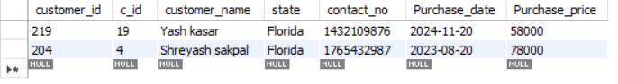

#1. Retrieve the details of customers who purchased cars with a horsepower greater than 300:

SELECT * FROM car_sales WHERE c_id IN (SELECT car_id FROM car_desc WHERE Horsepower > 300);vb

|  |  |  |  |  |  |  |
| --- | --- | --- | --- | --- | --- | --- |
|  |  |  |  |  |  |  |
| 203 | 3 | Rohit waje | Texas | 1357924680 | 2023-07-15 | 44000 |
| 204 | 4 | Shreyash sakpal | Florida | 1765432987 | 2023-08-20 | 78000 |
| 208 | 8 | Sanket khamkar | Florida | 1324509876 | 2023-12-05 | 62000 |
| 214 | 14 | Siddhay shetye | New York | 1432098765 | 2024-06-05 | 49000 |
| 220 | 20 | Aditya chavan | California | 1209876543 | 2024-12-25 | 26000 |
| 222 | 22 | Sarthak redij | Texas | 1765432109 | 2025-02-05 | 51000 |
| 223 | 23 | Vandesh chavan | Florida | 1543210987 | 2025-03-10 | 63000 |
| 226 | 26 | Afnan sabale | Texas | 1876543210 | 2025-06-25 | 42000 |
|  |  |  |  |  |  |  |

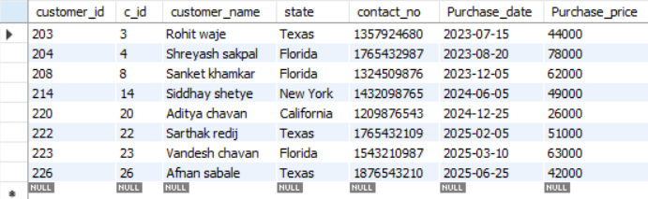

#2. Display the import details for electric cars (Engine_type = 'Electric'):

SELECT * FROM car_import WHERE Model_type IN (SELECT Model_name FROM car_desc WHERE Engine_type = 'Electric');

|  |  |  |  |  |
| --- | --- | --- | --- | --- |
| Import_id | Model_type | Company_name | Import_date | Import_price |
| 1004 | Tesla Model S | Tesla | 2022-05-10 | 75000 |
| 1019 | Tesla Model 3 | Tesla | 2023-08-20 | 51000 |
|  |  |  |  |  |

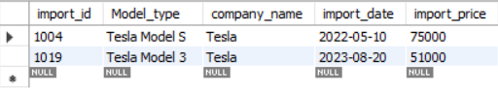

# Retrieve details of cars sold, including customer information using subqueries:

SELECT customer_id, customer_name, contact_no, Purchase_date, Purchase_price,

(SELECT Model_name FROM car_desc WHERE car_id = cs.c_id) AS Model_name FROM car_sales cs;

|  |  |  |  |  |  |
| --- | --- | --- | --- | --- | --- |
| Customer_id | Customer_name | Contact_no | Purchase_date | Purchase_price | model_name |
| 201 | Raj kadam | 1234567890 | 2023-05-01 | 27000 | Toyota Camry |
| 202 | Ganesh gurav | 1987654321 | 2023-06-10 | 21000 | Honda Civic |
| 203 | Rohit waje | 1357924680 | 2023-07-15 | 44000 | Ford Mustang |
| 204 | Shreyash sakpal | 1765432987 | 2023-08-20 | 78000 | Tesla Model S |
| 205 | Sejal bhekare | 1654329870 | 2023-09-25 | 36000 | BMW 3 Series |
| 206 | Kapil ghag | 1890765432 | 2023-10-30 | 32000 | Audi A4 |
| 207 | Vishal rajbhar | 1209876543 | 2023-11-02 | 50000 | Mercedes-Benz C-Class |
| 208 | Sanket khamkar | 1324509876 | 2023-12-05 | 62000 | Chevrolet Corvette |
| 209 | kalyani patel | 1789054321 | 2024-01-10 | 25000 | Nissan Altima |
| 210 | Priti yadav | 1543210987 | 2024-02-15 | 23000 | Hyundai Elantra |
| 211 | Angali tripathi | 1908765432 | 2024-03-20 | 46000 | Volvo S60 |
| 212 | Arun ovhal | 1123456789 | 2024-04-25 | 31000 | Mazda MX-5 Miata |
| 213 | Siddhesh bhekare | 1567890123 | 2024-05-30 | 37000 | Subaru WRX |
| 214 | Siddhay shetye | 1432098765 | 2024-06-05 | 49000 | Lexus ES |
| 215 | Manav sawardekar | 1976543210 | 2024-07-10 | 26000 | Kia Optima |
| 216 | Rutik adekar | 1098765432 | 2024-08-01 | 21000 | Toyota Corolla |
| 217 | Sonal patil | 1876543210 | 2024-09-10 | 27000 | Honda Accord |
| 218 | Amey shigwan | 1654321098 | 2024-10-15 | 34000 | Ford F-150 |
| 219 | Yash kasar | 1432109876 | 2024-11-20 | 58000 | Tesla Model 3 |
| 220 | Aditya chavan | 1209876543 | 2024-12-25 | 26000 | BMW 5 Series |
| 221 | Sumeet sannak | 1987654321 | 2025-01-30 | 32000 | Audi Q5 |
| 222 | Sarthak redij | 1765432109 | 2025-02-05 | 51000 | Mercedes-Benz  E-Class |
| 223 | Vandesh chavan | 1543210987 | 2025-03-10 | 63000 | Chevrolet Silverado |
| 224 | Yuvraj kadam | 1321098765 | 2025-04-15 | 24000 | Nissan Rogue |
| 225 | Shantanu chavan | 1098765432 | 2025-05-20 | 22000 | Hyundai Sonata |
| 226 | Afnan sabale | 1876543210 | 2025-06-25 | 42000 | Volvo XC60 |
| 227 | Karina kadam | 1654321098 | 2025-07-30 | 29000 | Mazda CX-5 |
| 228 | Isha kadam | 1432109876 | 2025-08-05 | 33000 | Subaru Outback |
| 229 | Narendra sakpal | 1209876543 | 2025-09-10 | 50000 | Lexus RX |
| 230 | Anita kadam | 1987654321 | 2025-10-15 | 25000 | Kia Sorento |

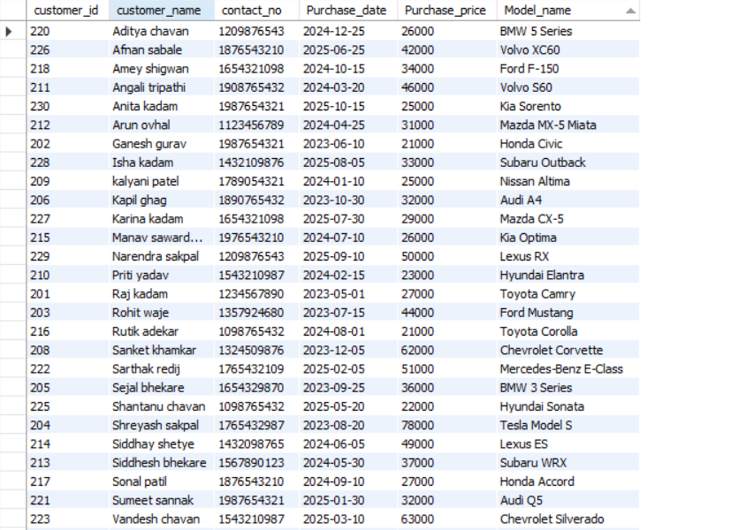



# Retrieve the names of customers who purchased cars and the corresponding model names using subqueries:

SELECT customer_name, (SELECT Model_name FROM car_desc WHERE car_id = cs.c_id) AS Model_name FROM car_sales cs;

|  |  |
| --- | --- |
| Customer_name | Model_name |
| Raj kadam | Toyota Camry |
| Ganesh gurav | Honda Civic |
| Rohit waje | Ford Mustang |
| Shreyash sakpal | Tesla Model S |
| Sejal bhekare | BMW 3 Series |
| Kapil ghag | Audi A4 |
| Vishal rajbhar | Mercedes-Benz C-Class |
| Sanket khamkar | Chevrolet Corvette |
| kalyani patel | Nissan Altima |
| Priti yadav | Hyundai Elantra |
| Angali tripathi | Volvo S60 |
| Arun ovhal | Mazda MX-5 Miata |
| Siddhesh bhekare | Subaru WRX |
| Siddhay shetye | Lexus ES |
| Manav sawardekar | Kia Optima |
| Rutik adekar | Toyota Corolla |
| Sonal patil | Honda Accord |
| Amey shigwan | Ford F-150 |
| Yash kasar | Tesla Model 3 |
| Aditya chavan | BMW 5 Series |
| Sumeet sannak | Audi Q5 |
| Sarthak redij | Mercedes-Benz E-Class |
| Vandesh chavan | Chevrolet Silverado |
| Yuvraj kadam | Nissan Rogue |
| Shantanu chavan | Hyundai Sonata |
| Afnan sabale | Volvo XC60 |
| Karina kadam | Mazda CX-5 |
| Isha kadam | Subaru Outback |
| Narendra sakpal | Lexus RX |
| Anita kadam | Kia Sorento |

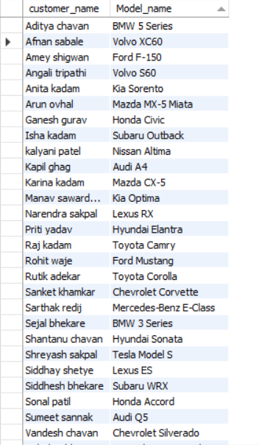

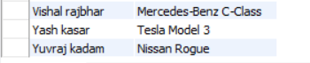

**JOINS**

#Inner Join to Retrieve Sales Information with Car Description:

select cd.Model_name, cs.customer_name, cs.Purchase_date from car_desc cd inner join car_sales cs on cd.car_id = cs.c_id;

|  |  |  |
| --- | --- | --- |
| Model_name | Customer_name | Purchase_date |
| Toyota Camry | Raj kadam | 2023-05-01 |
| Honda Civic | Ganesh gurav | 2023-06-10 |
| Ford Mustang | Rohit waje | 2023-07-15 |
| Tesla Model S | Shreyash sakpal | 2023-08-20 |
| BMW 3 Series | Sejal bhekare | 2023-09-25 |
| Audi A4 | Kapil ghag | 2023-10-30 |
| Mercedes-Benz C-Class | Vishal rajbhar | 2023-11-02 |
| Chevrolet Corvette | Sanket khamkar | 2023-12-05 |
| Nissan Altima | kalyani patel | 2024-01-10 |
| Hyundai Elantra | Priti Yadav | 2024-02-15 |
| Volvo S60 | Angali Tripathi | 2024-03-20 |
| Mazda MX-5 Miata | Arun ovhal | 2024-04-25 |
| Subaru WRX | Siddhesh bhekare | 2024-05-30 |
| Lexus ES | Siddhay shetye | 2024-06-05 |
| Kia Optima | Manav sawardekar | 2024-07-10 |
| Toyota Corolla | Rutik adekar | 2024-08-01 |
| Honda Accord | Sonal patil | 2024-09-10 |
| Ford F-150 | Amey shigwan | 2024-10-15 |
| Tesla Model 3 | Yash kasar | 2024-11-20 |
| BMW 5 Series | Aditya chavan | 2024-12-25 |
| Audi Q5 | Sumeet sannak | 2025-01-30 |
| Mercedes-Benz E-Class | Sarthak redij | 2025-02-05 |
| Chevrolet Silverado | Vandesh chavan | 2025-03-10 |
| Nissan Rogue | Yuvraj kadam | 2025-04-15 |
| Hyundai Sonata | Shantanu chavan | 2025-05-20 |
| Volvo XC60 | Afnan sabale | 2025-06-25 |
| Mazda CX-5 | Karina kadam | 2025-07-30 |
| Subaru Outback | Isha kadam | 2025-08-05 |
| Lexus RX | Narendra sakpal | 2025-09-10 |
| Kia Sorento | Anita kadam | 2025-10-15 |

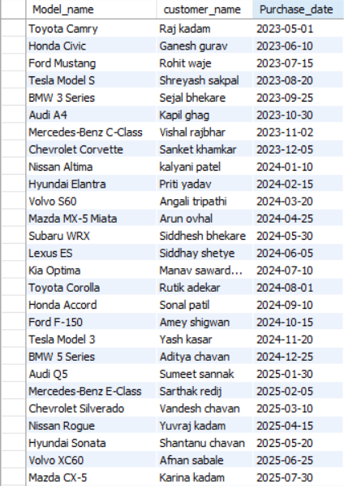

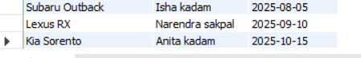

#Join to Show Sales with Car Description and Imported Car Company:

select cs.customer_name, cd.Model_name, ci.company_name from car_sales cs inner join car_desc cd on cs.c_id = cd.car_id inner join car_import ci on cd.Model_name = ci.Model_type;

|  |  |  |
| --- | --- | --- |
| Customer_name | Model_name | Company_name |
| Raj kadam | Toyota Camry | Toyota |
| Ganesh gurav | Honda Civic | Honda |
| Rohit waje | Ford Mustang | Ford |
| Shreyash sakpal | Tesla Model S | Tesla |
| Sejal bhekare | BMW 3 Series | BMW |
| Kapil ghag | Audi A4 | Audi |
| Vishal rajbhar | Mercedes-Benz C-Class | Mercedes-Benz |
| Sanket khamkar | Chevrolet Corvette | Chevrolet |
| kalyani patel | Nissan Altima | Nissan |
| Priti yadav | Hyundai Elantra | Hyundai |
| Angali tripathi | Volvo S60 | Volvo |
| Arun ovhal | Mazda MX-5 Miata | Mazda |
| Siddhesh bhekare | Subaru WRX | Subaru |
| Siddhay shetye | Lexus ES | Lexus |
| Manav sawardekar | Kia Optima | Kia |
| Rutik adekar | Toyota Corolla | Toyota |
| Sonal patil | Honda Accord | Honda |
| Amey shigwan | Ford F-150 | Ford |
| Yash kasar | Tesla Model 3 | Tesla |
| Aditya chavan | BMW 5 Series | BMW |
| Sumeet sannak | Audi Q5 | Audi |
| Sarthak redij | Mercedes-Benz E-Class | Mercedes |
| Vandesh chavan | Chevrolet Silverado | Chevrolet |
| Yuvraj kadam | Nissan Rogue | Nissan |
| Shantanu chavan | Hyundai Sonata | Hyundai |
| Afnan sabale | Volvo XC60 | Volvo |
| Karina kadam | Mazda CX-5 | Mazda |
| Isha kadam | Subaru Outback | Subaru |
| Narendra sakpal | Lexus RX | Lexus |
| Anita kadam | Kia Sorento | Kia |

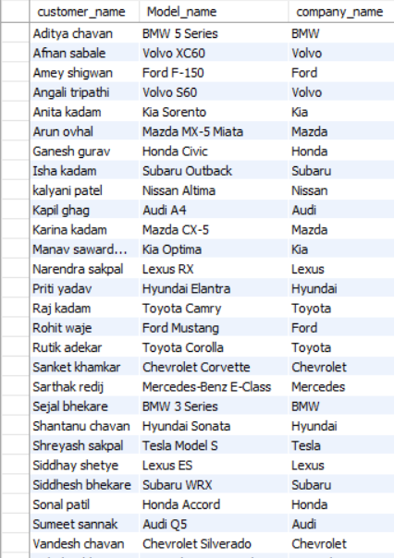

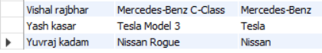

#Join to Show Car Sales, Description, and Imported Car Details:

SELECT cs.customer_name, cd.Model_name, ci.company_name, ci.import_price from car_sales cs

inner join car_desc cd on cs.c_id = cd.car_id inner join car_import ci on cd.Model_name = ci.Model_type;

|  |  |  |  |
| --- | --- | --- | --- |
| Customer_price | Model_name | Company_name | Import_price |
| Raj kadam | Toyota Camry | Toyota | 23000 |
| Ganesh gurav | Honda Civic | Honda | 20000 |
| Rohit waje | Ford Mustang | Ford | 42000 |
| Shreyash sakpal | Tesla Model S | Tesla | 75000 |
| Sejal bhekare | BMW 3 Series | BMW | 38000 |
| Kapil ghag | Audi A4 | Audi | 34000 |
| Vishal rajbhar | Mercedes-Benz C-Class | Mercedes-Benz | 48000 |
| Sanket khamkar | Chevrolet Corvette | Chevrolet | 58000 |
| kalyani patel | Nissan Altima | Nissan | 21000 |
| Priti yadav | Hyundai Elantra | Hyundai | 19000 |
| Angali tripathi | Volvo S60 | Volvo | 42000 |
| Arun ovhal | Mazda MX-5 Miata | Mazda | 28000 |
| Siddhesh bhekare | Subaru WRX | Subaru | 33000 |
| Siddhay shetye | Lexus ES | Lexus | 45000 |
| Manav sawardekar | Kia Optima | Kia | 22000 |
| Rutik adekar | Toyota Corolla | Toyota | 19000 |
| Sonal patil | Honda Accord | Honda | 24000 |
| Amey shigwan | Ford F-150 | Ford | 32000 |
| Yash kasar | Tesla Model 3 | Tesla | 51000 |
| Aditya chavan | BMW 5 Series | BMW | 48000 |
| Sumeet sannak | Audi Q5 | Audi | 42000 |
| Sarthak redij | Mercedes-Benz E-Class | Mercedes | 57000 |
| Vandesh chavan | Chevrolet Silverado | Chevrolet | 38000 |
| Yuvraj kadam | Nissan Rogue | Nissan | 25000 |
| Shantanu chavan | Hyundai Sonata | Hyundai | 21000 |
| Afnan sabale | Volvo XC60 | Volvo | 46000 |
| Karina kadam | Mazda CX-5 | Mazda | 27000 |
| Isha kadam | Subaru Outback | Subaru | 30000 |
| Narendra sakpal | Lexus RX | Lexus | 53000 |
| Anita kadam | Kia Sorento | Kia | 26000 |

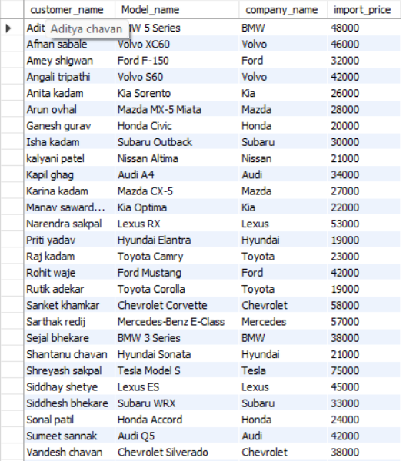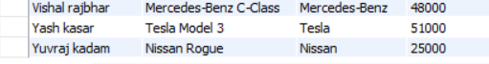

#Join to Display Car Sales and Description with Imported Car Price:

select cd.Model_name, cs.customer_name, ci.import_price from car_sales cs

inner join car_desc cd on cs.c_id = cd.car_id inner join car_import ci on cd.Model_name = ci.Model_type;

|  |  |  |
| --- | --- | --- |
| Model_name | Customer_name | Import_price |
| Toyota Camry | Raj kadam | 23000 |
| Honda Civic | Ganesh gurav | 20000 |
| Ford Mustang | Rohit waje | 42000 |
| Tesla Model S | Shreyash sakpal | 75000 |
| BMW 3 Series | Sejal bhekare | 38000 |
| Audi A4 | Kapil ghag | 34000 |
| Mercedes-Benz C-Class | Vishal rajbhar | 48000 |
| Chevrolet Corvette | Sanket khamkar | 58000 |
| Nissan Altima | kalyani patel | 21000 |
| Hyundai Elantra | Priti Yadav | 19000 |
| Volvo S60 | Angali Tripathi | 42000 |
| Mazda MX-5 Miata | Arun ovhal | 28000 |
| Subaru WRX | Siddhesh bhekare | 33000 |
| Lexus ES | Siddhay shetye | 45000 |
| Kia Optima | Manav sawardekar | 22000 |
| Toyota Corolla | Rutik adekar | 19000 |
| Honda Accord | Sonal patil | 24000 |
| Ford F-150 | Amey shigwan | 32000 |
| Tesla Model 3 | Yash kasar | 51000 |
| BMW 5 Series | Aditya chavan | 48000 |
| Audi Q5 | Sumeet sannak | 42000 |
| Mercedes-Benz E-Class | Sarthak redij | 57000 |
| Chevrolet Silverado | Vandesh chavan | 38000 |
| Nissan Rogue | Yuvraj kadam | 25000 |
| Hyundai Sonata | Shantanu chavan | 21000 |
| Volvo XC60 | Afnan sabale | 46000 |
| Mazda CX-5 | Karina kadam | 27000 |
| Subaru Outback | Isha kadam | 30000 |
| Lexus RX | Narendra sakpal | 53000 |
| Kia Sorento | Anita kadam | 26000 |

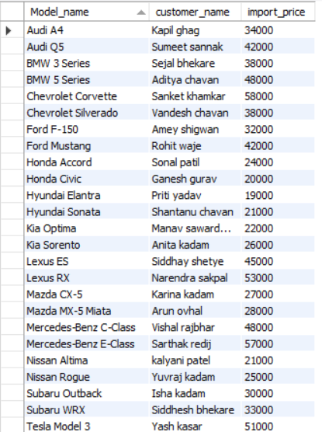

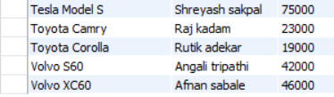

#4. Retrieve the names of customers who purchased cars and the corresponding model names:

SELECT cs.customer_name, cd.Model_name FROM car_sales cs JOIN car_desc cd ON cs.c_id = cd.car_id;

|  |  |
| --- | --- |
| Customer_name | Model_name |
| Aditya chavan | BMW 5 Series |
| Afnan sabale | Volvo XC60 |
| Amey shigwan | Ford F-150 |
| Angali tripathi | Volvo S60 |
| Anita kadam | Kia Sorento |
| Arun ovhal | Mazda MX-5 Miata |
| Ganesh gurav | Honda Civic |
| Isha kadam | Subaru Outback |
| kalyani patel | Nissan Altima |
| Kapil ghag | Audi A4 |
| Karina kadam | Mazda CX-5 |
| Manav sawardekar | Kia Optima |
| Narendra sakpal | Lexus RX |
| Priti yadav | Hyundai Elantra |
| Raj kadam | Toyota Camry |
| Rohit waje | Ford Mustang |
| Rutik adekar | Toyota Corolla |
| Sanket khamkar | Chevrolet Corvette |
| Sarthak redij | Mercedes-Benz E-Class |
| Sejal bhekare | BMW 3 Series |
| Shantanu chavan | Hyundai Sonata |
| Shreyash sakpal | Tesla Model S |
| Siddhay shetye | Lexus ES |
| Siddhesh bhekare | Subaru WRX |
| Sonal patil | Honda Accord |
| Sumeet sannak | Audi Q5 |
| Vandesh chavan | Chevrolet Silverado |
| Vishal rajbhar | Mercedes-Benz C-Class |
| Yash kasar | Tesla Model 3 |
| Yuv raj kadam | Nissan Rogue |

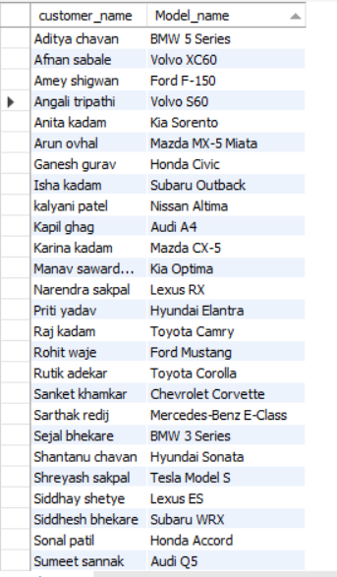

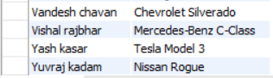

**CONCLUSION**

A well-designed car showroom database management system (DBMS) using MySQL offers a comprehensive solution for efficiently managing and organizing various aspects of a car showroom. This project has been structured to enhance the overall workflow and operations within the showroom, improving customer service, inventory management, and administrative tasks.

Through the development of this system, key objectives have been achieved:

**Efficient Inventory Management:**

The system allows for precise tracking and management of the available cars, their specifications, quantities, and status. It provides real-time updates, enabling the showroom to optimize stock levels and meet customer demands effectively.

**Enhanced Customer Experience:**

With functionalities such as quick search, detailed car information, and easy appointment scheduling, the system facilitates a seamless experience for customers. It allows them to explore available cars, compare specifications, and make informed decisions.

**Streamlined Sales Process:**

The integration of sales modules automates the sales process, from initial inquiries to closing deals, reducing manual effort and minimizing errors. It ensures accurate documentation and reporting for sales transactions.

**Improved Reporting and Analysis:**

The system generates comprehensive reports on sales, inventory, and customer interactions. This data aids in making informed business decisions, identifying trends, and implementing strategies to enhance the showroom's performance.

**Administrative Efficiency:**

The system simplifies administrative tasks such as employee management, user access controls, and maintenance scheduling. It enhances overall operational efficiency by automating routine tasks.

In conclusion, the Car Showroom Database Management System developed using MySQL serves as a robust and user-friendly platform that significantly improves the functionality and productivity of the showroom. It empowers both showroom staff and customers by providing a cohesive and streamlined experience, ultimately contributing to the success and growth of the business in a competitive automotive market. Continued updates and improvements to this system will ensure it remains adaptable to evolving industry requirements, technological advancements, and customer needs.

**THANK YOU**

+